Purpose:
The Nicola Naturalist Society was formed in 2010, based in Merritt, BC. Membership is open to anyone interested in nature, wildlife and the health of local ecosystems. Along with more than 50 other naturalist clubs in British Columbia, they are a member of BC Nature (Federation of BC Naturalists).

A major objective of the Nicola Naturalist Society is to provide education and information on the wild organisms and ecosystems of the BC interior, especially those, found in the Nicola Valley and surrounding areas.

Eligibility:
The award recognizes a full-time, graduating first year Environmental Resources Technology (ENRT) student from NVIT at the Merritt campus expecting to continue into his/her second year of studies of ENRT at NVIT. The applicant must demonstrate high academic achievement, motivation, self-discipline, and dedication to his/her studies, and plan on pursuing a career in the Environmental and/or Natural Resources Field. The applicant must also be a Canadian citizen.

Value:
The Nicola Naturalist Society will donate one (1) award of $1000 to be distributed at the annual NVIT awards ceremony. The recipient will be expected to attend the first evening meeting of the Nicola Naturalist Society after that date.

Process:
Students must complete the following application process.

⃝ Complete and sign the application form;
⃝ Submit the recommendation form completed and signed by an NVIT Environmental Resources Technology Faculty Member;
⃝ Write a 300-500 word, typed essay answering the following questions, “What have you learned in the program that will apply to your future?” and “How will your learning help you in future field work?”; and
⃝ Submit an NVIT transcript.

Deadline:
The NVIT Registration Office must receive applications by 4:30pm on August 15, 2026. If August 15th lands on a weekend, the application will be due the last business day before the deadline. Please email a copy to awards@nvit.ca or drop off the original copy at the front desk of either campus; faxes and/or photocopies will not be accepted. Reference letters must also be submitted through email to awards@nvit.ca.
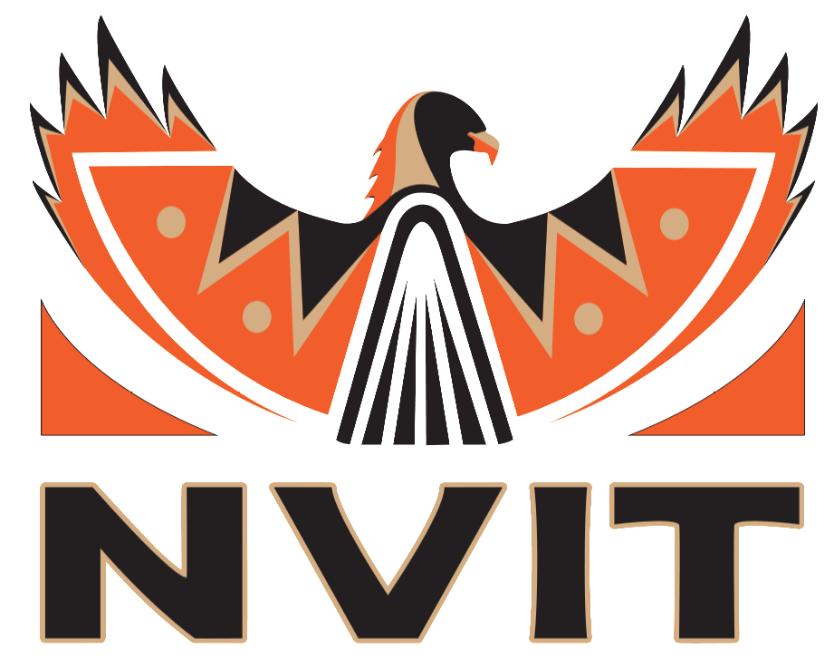
Students may appeal the award decision by submitting a written letter to the awards adjudication committee attention:

Nicola Naturalist Society Entrance Scholarship
c/o Registration Office
Nicola Valley Institute of Technology-Merritt Campus
4155 Belshaw Street Merritt, BC V1K 1R1
awards@nvit.ca

Please keep the front page for your own informational purposes.
PERSONAL INFORMATION:
Name:

Last First Middle Initial

Permanent Mailing Address

(_______) _______ - ____________ ________________________ _______/_______/____________
Telephone Student ID Date of Birth (MM/DD/YYYY)

_______ - _______ - _______
S.I.N.

Checklist:

[Please ensure all information is attached and completed. Incomplete applications will not be accepted.]

⃝ Complete and sign the application form;

⃝ Submit, in a sealed envelope, the recommendation form completed and signed by an NVIT Environmental Resources Technology Faculty Member;

⃝ Write a 300-500 word typed essay answering the following questions, “What have you learned in the program that will apply to your future?” and “How will your learning help you in future field work?”; and

⃝ Submit an NVIT transcript.

Applicant’s Declaration:
I confirm, all the information I have given in my application package is correct to the best of my knowledge.

Signature: ______________________________________ Date: (mm/dd/yyyy) ______/______/____________

Instructor Nomination:
Thank you for taking time to complete this instructor nomination. After completing the form, please place it in a sealed envelope and sign atop the back seal. Once sealed, you can provide the envelope back to the applicant.

Nomination Declaration:
With my signature below, I, ________________________________, (NVIT Environmental Resources Technology Faculty Member), nominate the following student for the Nicola Naturalist Society Bursary.

__________________________________________________________________
(please print the applicant’s name in BLOCK LETTERS)

Signature: ________________________________________________ Date: (yy/mm/dd) ______/______/________

Instructor Recommendation:
This recommendation letter must demonstrate the applicant's motivation and self-discipline, familiarity with the applicant’s classroom behavior and academic ability. It must show the awards committee, the applicant is dedicated to his/her education and has made a good impression on the educational community while enrolled at NVIT.

How does the applicant demonstrate outstanding leadership?

How does the applicant perform academically?

Has the applicant won any awards?

Has the applicant participated in any interscholastic/extracurricular activities?

Additional comments:

If more space is required, please use the backside of this form.

