Purpose:
Native Northwest is a company that supports Indigenous Arts and Culture in Canada. They are Indigenous-focused and publish children’s books, artwork and other items that promote Indigeneity. Native Northwest’s story began over 38 years ago with a social worker, a rack of postcards, and the vision of building everyday connection to Indigenous cultures. The values behind the Native Northwest brand originate with the founding reason for the company: Native arts and cultures, designed by Indigenous artists, built on a foundation of respect and authenticity. We tie authentic designs to bold, new concepts where artists can tell the stories of their communities and cultures through their distinct designs. Native Northwest operates on the Musqueam, Coast Salish territory in Vancouver, British Columbia.

Amount:
Two (2) bursaries of $500 each, will be provided at the awards ceremony by Native Northwest to support Indigenous learners in their studies.

Eligibility Criteria:
This bursary is open to self-identified Indigenous learners from any campus (community programs included) who are enrolled in a minimum 60% course load for the for the upcoming academic year. This entrance bursary is open to learners enrolled in any field of college-level study (Developmental Education, Employment Skills Access, Bridging to Trades and Micro-credentials are excluded). The bursary application, proof of enrolment (via transcripts or a registration statement) and a 300-word essay describing dedication to Indigenous arts and/or culture are required to be eligible for this award.

Checklist:
- Self-Identify as Indigenous;
- Complete and sign the application;
- Submit a proof of enrolment in a full-time course load in any program (60% or higher) for the 26/27 academic year at any NVIT campus via an NVIT Transcript or registration statement; and
- Submit a personal essay.
- 300 words, typed-written, double-spaced personal essay describing your dedication to Indigenous arts and/or culture.

Deadline:
The NVIT Registration Office must receive applications by 4:30pm on August 15, 2026. If August 15th lands on a weekend, the application will be due the last business day before the deadline. Please email a copy to awards@nvit.ca or drop off the original copy at the front desk of either campus; faxes and/or photocopies will not be accepted. Reference letters must also be submitted through email to awards@nvit.ca.
Students may appeal the award decision by submitting a written letter to the awards adjudication committee attention:
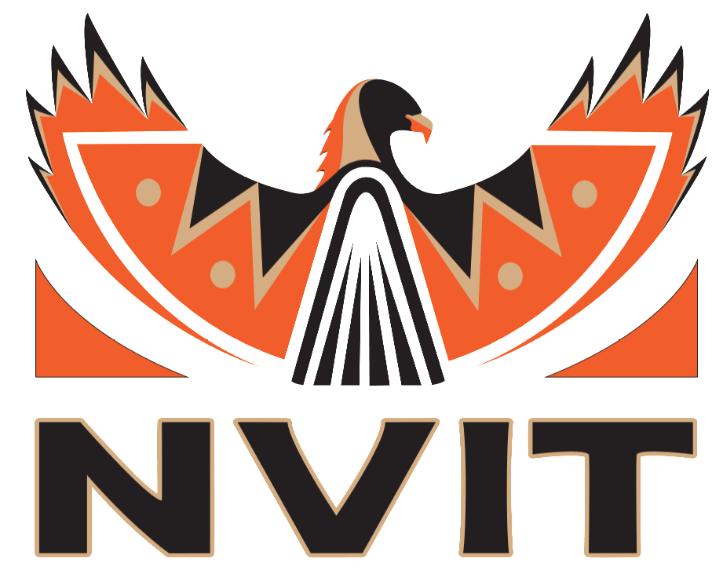
Native Northwest Reconciliation Entrance Bursary
c/o Registrar’s Office
Nicola Valley Institute of Technology
4155 Belshaw St. Merritt, BC V1K 1R1
awards@nvit.ca

Please keep the front page for your own informational purposes.
PERSONAL INFORMATION:
_________________________________________________________________________________________________________________
Name: Last First Middle Initial

_________________________________________________________________________________________________________________
Permanent Mailing Address

(_____) _____ - __________ _________________ ______/______/___________
Telephone Student ID Date of Birth (MM/DD/YYYY)

______________________________________________________________ _____ - _____ - _____
Email S.I.N.

Ancestry: Métis Inuit First Nations Status
First Nations Non-Status Other: ______________________________________________

What program are you enrolled in for the 26/27 academic year?
_________________________________________________________________________________________________________________

How will this bursary help you succeed in your academic journey?

Application Checklist: (Please ensure all of the following information is submitted in your application package; incomplete applications will not be accepted.)

- Self-Identify as Indigenous;
- Application;
- Proof of enrolment in a full-time course load in any program (60% or higher) for the 25/26 academic year at any NVIT Campus via an unofficial NVIT Transcript or registration statement; and
- Personal Essay.
- 300 words, typed-written, double-spaced personal essay describing your dedication to Indigenous arts and/or culture.

Applicants’ Declaration:
I hereby declare the information on this application is, to the best of my knowledge, complete and accurate. I acknowledge the information will be used to determine my eligibility for awards administered by NVIT and NVIT reserves the right to verify information on my application. If any of the information provided in this application should change, I understand it is my responsibly to advise the Registrar’s Office, in writing, of any such changes. Should I be awarded a scholarship, I agree my name and essay may be released to scholarship donors, my secondary school or college, and may appear in a published list of award winners.

Signature: ________________________________________________ Date: (yyyy/mm/dd) _______/_______/______

