Purpose:
The NVIT Student Society Entrance Award is designed to support learners who have paid the student activity fee during their educational journey at NVIT.

Amount:
Two (2) awards of $1,000 each will be provided by NVIT Student Society to support a learner at our annual awards ceremony.

Eligibility Criteria:
This award is open to any learner of any age with a full-time or part-time course load, registered in any program on the Merritt campus, Vancouver campus or a Community Education student within 100kms of the Merritt campus, who pays the student activity fee.

Checklist:
- Complete and sign the application.
- Submit a proof of enrolment in a full-time or part-time course load in any program for the 26/27 academic year at the Merritt or Vancouver Campuses, or in a Community Education program within 100kms of the Merritt campus that charges the student activity fee, via an NVIT registration statement.
- Answer the application statement question: How do you see this Award supporting your educational journey?

Deadline:
The NVIT Registration Office must receive applications by 4:30pm on August 15, 2026. If August 15th lands on a weekend, the application will be due the last business day before the deadline. Please email a copy to awards@nvit.ca or drop off the original copy at the front desk of either campus; faxes and/or photocopies will not be accepted. Reference letters must also be submitted through email to awards@nvit.ca.
Students may appeal the award decision by submitting a written letter to the awards adjudication committee attention:
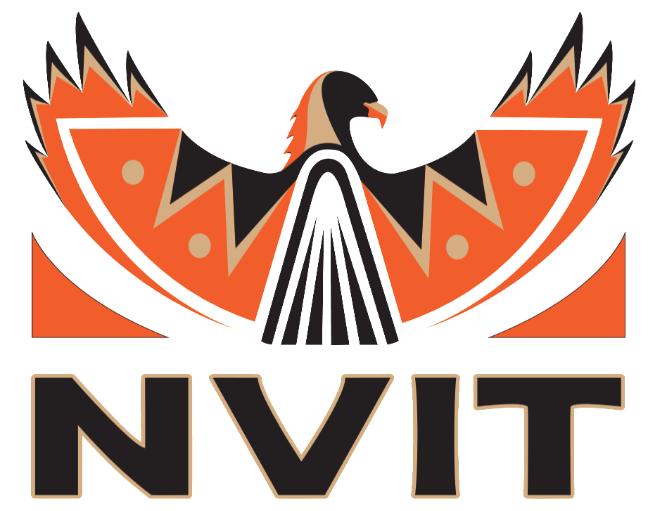
NVIT Student Society Entrance Award
Registrar’s Office
Nicola Valley Institute of Technology
4155 Belshaw Street Merritt, BC V1K 1R1
awards@nvit.ca

Please keep the front page for your own informational purposes.
PERSONAL INFORMATION:
_________________________________________________________________________________________________________________
Name: Last First Middle Initial

_________________________________________________________________________________________________________________
Permanent Mailing Address

(_____) _____ - __________ _________________ ______/______/___________
Telephone Student ID Date of Birth (MM/DD/YYYY)

______________________________________________________________ _____ - _____ - _____
Email S.I.N.

What program are you enrolled in for the 24/25 academic year?
_________________________________________________________________________________________________________________

What campus will you be attending?
__________________________________________

How will this bursary help you succeed in your academic journey? 500 words max. May submit answer with an attachment if needed.

Checklist:
- Complete and sign the application.
- Submit a proof of enrolment in a full-time or part-time course load in any program for the 26/27 academic year at the Merritt or Vancouver Campuses, or in a Community Education program within 100kms of the Merritt campus that charges the student activity fee, via an NVIT registration statement.
- Answer the application statement question: How do you see this Award supporting your educational journey?

Applicant’s Declaration:
I hereby declare the information on this application is, to the best of my knowledge, complete and accurate. I acknowledge the information will be used to determine my eligibility for awards administered by NVIT and NVIT reserves the right to verify information on my application. If any of the information provided in this application should change, I understand it is my responsibly to advise the Registrar’s Office, in writing, of any such changes. Should I be awarded a scholarship, I agree my name and essay may be released to scholarship donors, my secondary school or college, and may appear in a published list of award winners.

Signature: ____________________________________________________________ Date: (yyyy/mm/dd) _______/_______/______

