Purpose:
As a permanent resident of the Nicola Valley and member of the Lower Nicola Indian Band, Mr. Shuter graduated from NVIT in 2013 with an Associate of ARTS degree. As an active philanthropist in the Nicola Valley, Mitchell is an advocate for life-long learning and healthy lifestyle. He is a sports enthusiast at heart with a passion for hockey, baseball and basketball. Through the entrance awards, Mr. Shuter wishes to acknowledge those who share his commitment to personal advancement and growth. Recognizing there are occasional speed-bumps along the way, Mr. Shuter offers an entrance award for those choosing to return to school and to those who have demonstrated a balanced lifestyle during their secondary school experience.

Eligibility:
There will be two (2) entrance award categories disbursed each year to recipients of Indigenous ancestry enrolled in a certificate or diploma program at the Eagles Perch-Merritt Campus enrolled in a minimum 80% course load. One award to a mature student (an individual that is at least 35 years of age and has been out of formal education for a minimum of five years) and one to a Nicola Valley Secondary School graduate. Students cannot have previously attended post-secondary studies or have been funded through the secondary school ACE-IT program. Successful recipients must also demonstrate consistent commitment to active lifestyles and community leadership before and during their time at NVIT.

Amount:
NVIT Alumni, Mitchell W. Shuter, is pleased to offer two (2) entrance awards per year, valued at $2500 each and will be made in two disbursements; $1250 in September and $1250 in January; depending upon achieving a minimum 2.33 grade point average in the fall semester.

Criteria:
Student Checklist (All students must submit the following items to complete the application package.):
⃝ completed and signed application form
⃝ registration statement showing proof of a minimum 80% course load in the certificate/diploma program
⃝ copy of status card or letter from First Nations Band/Tribal Council showing proof of Indigenous ancestry
⃝ provide tangible evidence of continuous dedication to an active life-style
⃝ provide tangible evidence of continuous dedication to community (local or global) citizenship

⃝ Nicola Valley Secondary School Graduates must also submit a personal character reference letter from a teacher or secondary school support worker or administrator.

Deadline:
The NVIT Registration Office must receive applications by 4:30pm on August 15, 2026. If August 15th lands on a weekend, the application will be due the last business day before the deadline. Please email a copy to awards@nvit.ca or drop off the original copy at the front desk of either campus; faxes and/or photocopies will not be accepted. Reference letters must also be submitted through email to awards@nvit.ca.
Students may appeal the award decision by submitting a written letter to the awards adjudication committee attention:
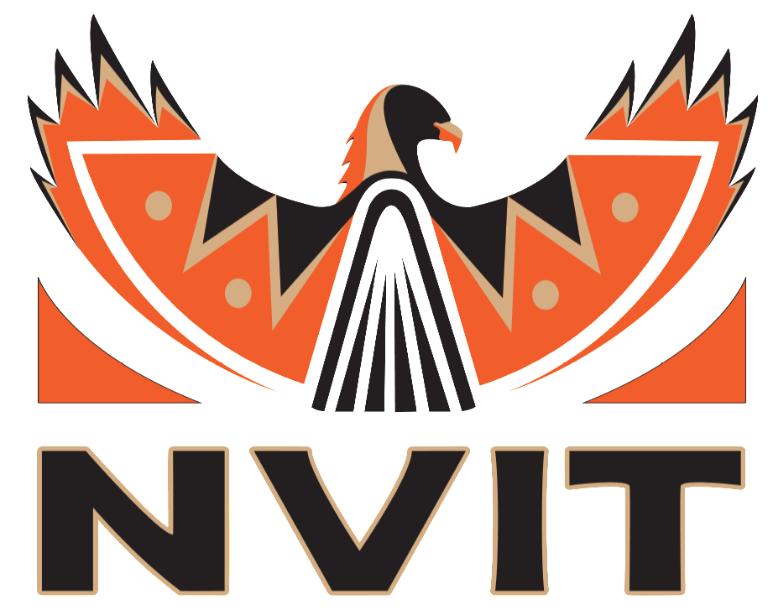

Mitchell W. Shuter Entrance Award
c/o Registration Office
Nicola Valley Institute of Technology-Merritt Campus
4155 Belshaw Street Merritt, BC V1K 1R1
awards@nvit.ca

Please keep the front page for your own informational purposes.

Please select the category of award you are applying for:

⃝ Mature Student ⃝ Nicola Valley Secondary School Graduate

PERSONAL INFORMATION:
Name:

Last First Middle Initial

Permanent Mailing Address

City: ____________________________________ Province: ___________ Postal Code:

(_______) _______ - ____________ _____________________ _____________/________/_____________
Telephone Student ID Date of Birth (MM/DD/YYYY)

_______ - _______ - _______

S.I.N. Email Address

Indigenous Affiliation (name of Band/Tribal Council):

EDUCATIONAL INFORMATION:
Name of Secondary School Attended:

Program you are currently enrolled at NVIT?

What year of studies are you currently enrolled in? ⃝ 1st ⃝ 2nd ⃝ 3rd ⃝ 4th

Student Checklist (All students must submit the following items to complete the application package.):
⃝ completed and signed application form
⃝ registration statement showing proof of a minimum 80% course load in the certificate/diploma program
⃝ copy of status card or letter from First Nations Band/Tribal Council showing proof of Indigenous ancestry
⃝ provide tangible evidence of continuous dedication to an active life-style
⃝ provide tangible evidence of continuous dedication to community (local or global) citizenship

⃝ Nicola Valley Secondary School Graduates must also submit a personal character reference letter from a teacher or secondary school support worker or administrator.

Student Declaration:
I hereby declare that the information on this declaration is, to the best of my knowledge, complete and accurate. I acknowledge that the information will be used to confirm my eligibility for awards administered by NVIT and that NVIT reserves the right to verify information on my declaration. If any of the information provided in this declaration should change, I understand that it is my responsibility to advise the Registration Office, in writing, of any such changes. I authorize the release of all secondary school interim and final grades and/or college/university grades to NVIT. As an award recipient, I agree that my name may be released to award donors, my secondary school or college, and may appear in a published list of award winners.

Signature: ___________________________________ Date (MM/DD/YYYY): ______/______/__________

